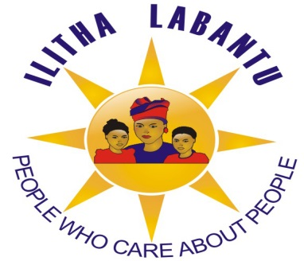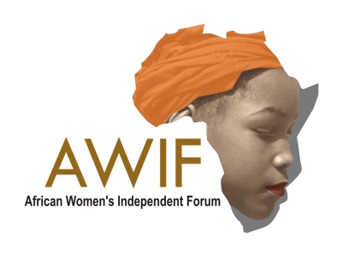

**African Women’s Independent Forum**

**& Ilitha Labantu**

National Summit on Ending Violence against Women & Protecting Human Rights and Dignity 26 – 28 August 2013

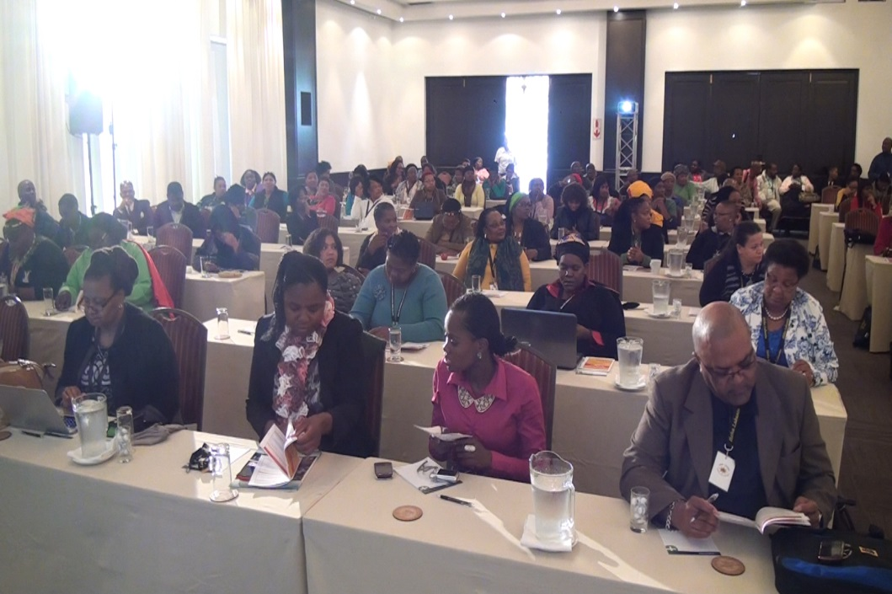

***Acknowledgment***

[](http://www.nlb.org.za/applicants-and-beneficiaries.html)

***We want to take this opportunity to acknowledge the contribution made by the National Lotteries Board towards the success of the National Summit.***

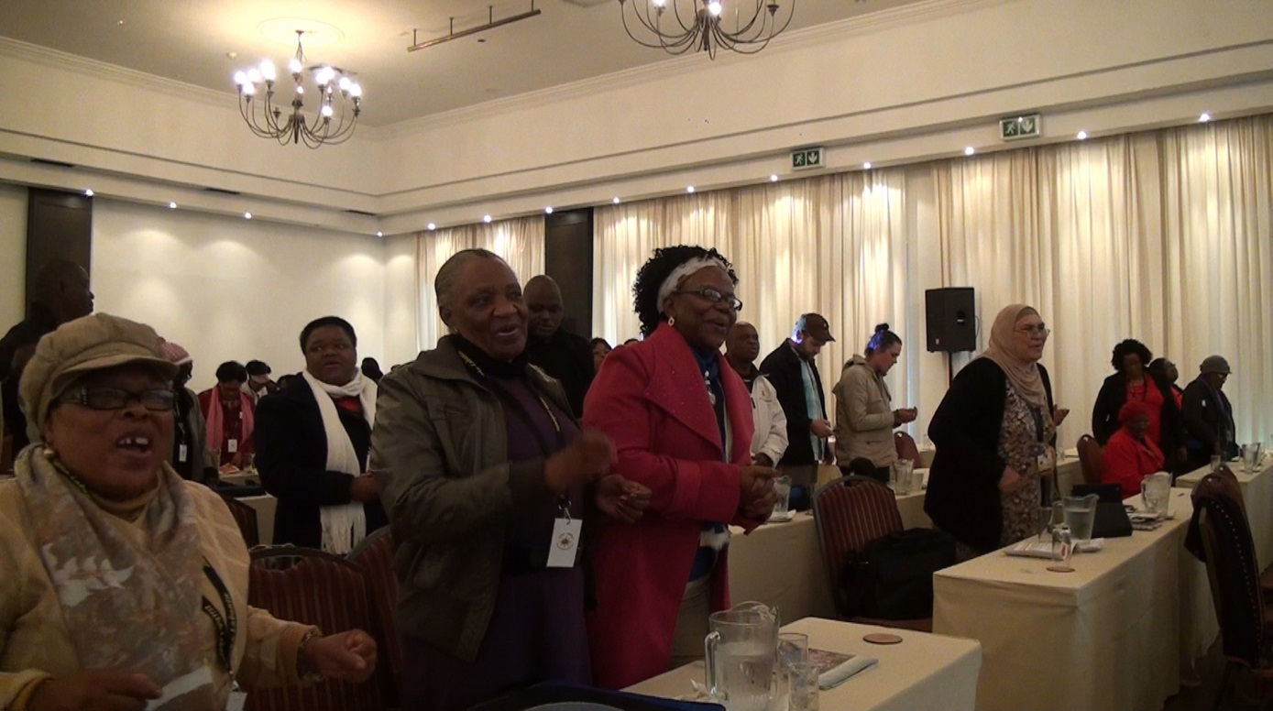

*Delegates from various Provinces*

***Content Page:***

1. Executive Summary Pg 3 - 4
2. Words of Wisdom Pg 4 - 5
3. Introduction Pg 6
4. Overview of VAW state in South Africa Pg 8
5. Commission on Gender Equality Pg 9
6. Deputy Minister of International Relations & Cooperation Pg 10
7. Southern Caucus of NGO’s Pg 10
8. Department of Social Development Pg 11
9. Premier of North West Pg 12 - 13
10. Presidency Liberia Pg 14
11. Justice & Constitutional Development Pg 14 - 15
12. Minister of Social Development Pg 16 - 18
13. DIRCO Pg 18
14. CONTRALESA Pg 18 - 19
15. National Lotteries Board Pg 19
16. National Development Agency Pg 19 - 20
17. ORAP – Zimbabwe Pg 21
18. Heinrich Bolls Foundation Pg 22
19. Sonke Gender Justice Pg 22 - 23
20. AU Gender Justice Pg 23
21. The important role of Civil Society on Ending VAW Pg 24 - 25
22. STATSSA Analysis on the present situation in South Africa Pg 25 - 26
23. STATSSA South Africa – Gender Report Pg 27 - 34
24. Activism Pg 35
25. African Women’s Independent Forum Pg 36 - 37
26. Recommendations from Panel Discussions Pg 38 - 39
27. Ilitha Labantu Pg 40
28. Musasa – Zimbabwe Pg 40
29. Closing Remarks & Core Issues of Discussion Pg 41 - 47
30. Conference Resolutions Pg 48 - 49
31. Resolutions Focused on Sexual Violence & Rape Pg 49 - 52

***Executive Summary:***

Violence against Women (VAW) is a complex problem and addressing it requires coordinated solutions involving the participation of both the state and civil society. Furthermore, the participation of all relevant stakeholders must be sought. Currently, activities are being conducted to address the issues at different institutional levels. Which needs to be discussed amongst each other and lessons shared to strengthen the actions for a more concentrated and cohesive effort.

The South African government has made considerable progress in prioritizing women’s rights. The government has created a national framework for addressing VAW through laws, policies, and campaigns. This has led to systematic changes where the rights of survivors are being addressed. The government has also worked with diverse stakeholder groups, and invested in educating the civil service and people on women’s rights. However, existing efforts must be expanded to address the causes of VAW, and the rights of survivors. Improved discourse and new initiatives that address VAW must also be pursued. There continues to be a need to undertake a holistic approach in addressing VAW, and focus on healing the bodies and minds of women who speak out against discrimination.

Men from around the country of different races, areas and origins also attended the National Summit on Ending Violence against Women, committing themselves to learn and share their knowledge in the fight against VAW and to creating a society where woman are seen as equals and partners. Ministers, Deputy Ministers, Representatives from the AU Commission, Directors of organisations, members of government, members of parliament, social workers, members of national and International organisations as well as representative from governments from more than eight cities attended, in the commitment to change the status quo for females in south Africa, enabling a more dignified, equal and just society for all. It has been largely recognised that within South Africa, gender inequality still persists, plagued with the challenges of economic instability, increased crime and violence of which involve woman who become the victims of such conditions.

This not only shows the immanent need and importance of this summit by Ilitha Labantu, but also facilitates awareness into the critical changes that need to take place and the factors therein that it is critical occurs for that to happen.

Woman from around the country, of different races, areas and origins congregated at this critical summit to discuss the imminent importance of protecting woman against violence, and the protection of human rights and dignity.

The four day summit was hosted at The Lord Charles Hotel, where discussions took place, from day tonight, where the finest minds and hearts of this county collaborated in the joining and partnerships of ideas, strategies and out of the box thinking of how to change the conscious action toward woman, for the betterment of all.

***Words of Wisdom and Blessings***

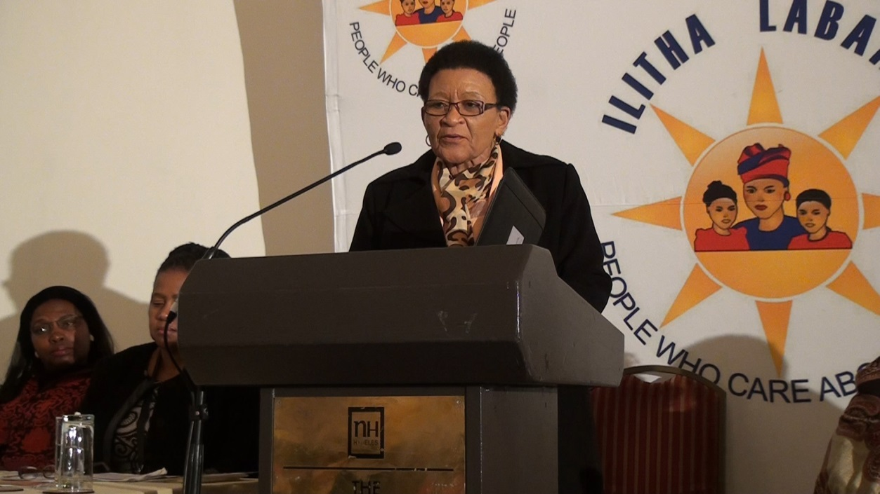

***Ms. Zikalala Member of Parliament***

The Summit was embraced the elderly, Mrs Constance Zikalala, Member of Parliament and Ms Natso Khumalo, Secretary General of the Veterans League. The aim of having the elderly during the national summit was for them to bless the proceedings of the summit, as well as offer words of wisdom and comfort for those involved in the women’s movement and fight against violence against women, to encourage them to continue in their strides create safer and empowering communities. One of the most crucial point that resonated amongst the elderly was the fact that the role of men in ending violence against woman is critical, and that for violence against woman to end, men need to active in their role, in preventing violence, and also understanding how and why it affects the community, their family, and its impact on woman who suffer from Violence and Abuse.

They emphasized the importance of men empowering each other to become advocated of violence against woman, as well as empowering them to influence each other in a positive manner. They further mentioned the fact that the perspective and view of men towards women was and is still that woman are considered as second class citizens, and are not at the forefront of society. Men need to actively engage in allowing women to share the power that they have gained over the decades and centuries, enabling women to become economically independent as well as financially independent. Global census has indicated that internationally, throughout all countries, women are still paid less than men. For violence against women to end, it becomes critical that men are active in the up-liftment and empowerment of women, by sharing resources, knowledge and offering women they know and support.

Women should no longer be in such a position of living in fear of men, but rather, were women and men works hand on hand in creating a better country. It is in the undoing of the centuries of social conditioning, whereby the woman was previously seen as an assistant onto man, but un-allowed and unable to proclaim the justice, dignity and honour that woman are naturally entitles to. They further advised that there is a great need for particular focus on woman in rural communities who are victims/survivors as a result of domestic violence and abuse. This is critical so, because statistics show that Violence against Women is strife in the rural communities, with woman and girl child’s being more vulnerable than ever before. As women in rural communities are often unable to aces assistance, shelters or to be educated the problem prevails in a ferocious manner, furthermore, within the communities, the mentalities, dogma’s and beliefs that hold women back remain deeply ingrained in the consciousness of that society.

In conclusion, the elderly mentioned that women’ movement organisation and government should also focus on the boy child. This is so because when the boy child witnesses his father beating up his mother, and is never able to learn any different, then it is easy to see and to understand why then the boy child, once developed into full adulthood, would see nothing wrong with abusing a woman. It is because of this practices entrenched as cultural practices and norms, that rigorous attention is needed in society, especially rural communities and informal settlements, to educate boys, girls, women, and well as men, not only through awareness programs but through experience sharing platforms, such as women being examples of how they have left abusive relationships, and men, advocates for the safety of woman.

***Introduction***

Ilitha Labantu believes that violence Against Women (VAW) is exacerbated by social pressures, notably the shame of denouncing certain acts that have been perpetrated against women; women's lack of access to legal information, aid or protection; the lack of laws that effectively prohibit violence against women; failure to reform existing laws; inadequate efforts on the part of public authorities to promote awareness of and enforce existing laws; and the absence of educational and other means to address the causes and consequences of violence. Women in South Africa particularly those leaving in disadvantage communities live within a patriarchal social system which reinforces gender inequalities. This patriarchal structure perpetuates values of honour, protection, and the sacredness of family; as well as dominion over women by the man.

It is an issue that affects millions of women and girls in cities all over the world. Both the causes and consequences of gender inequality and women’s lack of safety are interrelated and multi-faceted, encompassing such diverse issues as violence against women (VAW), access to basic services and employment, good governance, urban planning, and political participation. Violence against women and girls is increasingly recognized as one of the most serious and urgent challenges of our times. In all parts of the world, it’s very real and harmful effects on women and girls have been seen to impede the pursuit for development, peace and gender equality. The international community and civil society together have concluded that there are no circumstances that can excuse violence that targets women and girls — it is always a violation of their human rights, it is always a crime, and it is always unacceptable.

This has created a fervent fibre of social norms and cultural beliefs that influence individual legal choices that are used to perpetuate unruly and patriotic behaviour that has been normalised as an acceptable way of living. The national summit was aiming to outline lessons learned from South Africa and other countries around the globe, and to highlight the work of activists and survivor support mechanisms. The summit will also generate recommendations that are relevant to government agencies and community based organizations (CBOs). An emphasis will be placed on the promotion of policies, programs, community mobilization, and institutional reform that responds to the needs of survivors of violence by ensuring dignity and fundamental human rights. The purpose of the summit was to bring together leaders in the legal system, business, academia, research, not-for-profits organizations, advocacy and philanthropy to forge partnerships and provide opportunities to share information and resources. In addition to create a dialogue across national boundaries, and foster interactions between people who, though working toward common goals, often operate in isolation from each other.

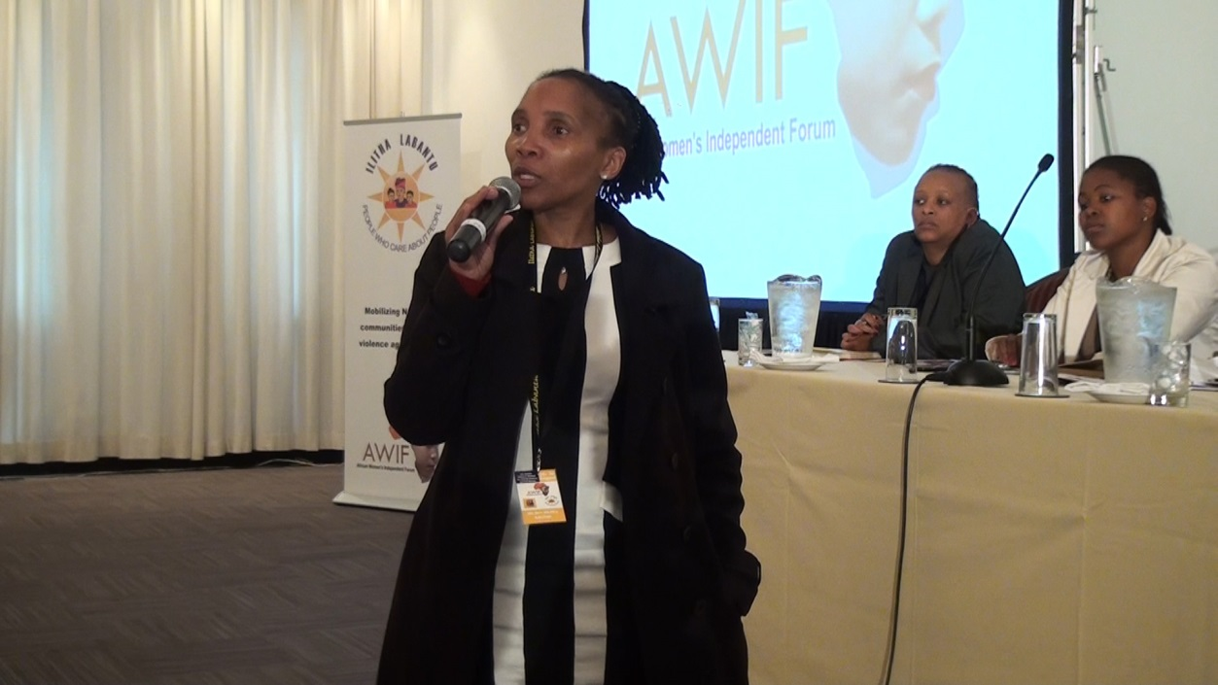

***Ms Buyi Majola Delegate from Gauteng***

***Overview of VAW state in South Africa by Ms Mandisa Monakali, founder of the African Independent Forum and Ilitha Labantu***

Ms. Mandisa Monakali referred to the South African history of the pass laws, the boycotts and the struggle for woman to attain equality, however said that the struggle is not over, and that today we need to take into account when fighting the scourge against woman today, and we must realize that the fight is not over yet, that as woman, we must still persist for our equality, we must still fight for the freedom of woman from violence, femicide and all forms of gender based violence. It is critical that as woman, we do not relax, and become complacent, because we ourselves may not be suffering.

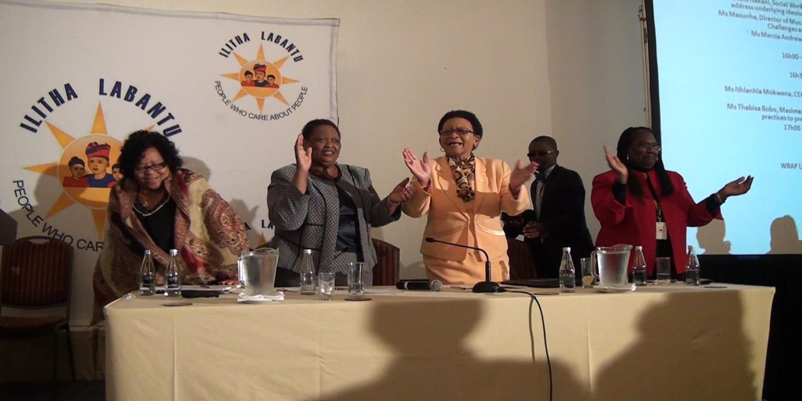For if one woman suffers then all women are suffering. And whilst there fight may be one that requires content persistence and endurance, if we give up now, then we have truly failed ourselves as woman, because then we are failing to protect our daughter and sisters of next generation. Ms. Mandisa Monakali spoke about how as woman, it is our critical responsibility, to ensure that we empower each other, and assist each other, motivate each other and share knowledge with each other to eradicate violence against woman.

*Ms. T Memela Deputy Chair NCOP, Ms. M Monakali Founder AWIF & IL, Ms Zikalala MP, Ms E Brown African Diaspora*

***Mr Mfanozelwe Shozi is the Acting Chairperson of the Commission for Gender Equality***

Mr Shozi stated that we know that poverty is the cause of gender base violence, and vice versa, hence we can no longer separate these two factors. The President Zuma said on May 2009, that this country must not stop, or rest until all poverty has been eradicated. It is clear that the issue of poverty being related to gender based violence is evident, and poverty cannot be eradicated until we deal with gender based violence.

Mr Shozi, also stated that at present gender based violence is a critical issue, in which no country can economically develop, if gender based violence has not been addressed. Woman should no longer be oppressed in any way or manner. Women remain critical in the upholding of a family, and need to be empowered in their role of society, the greater family.

In addition, we can no longer allow a society to continue where it is suggested that a woman was raped because of how she was dressed, her sexual orientation, or just the fact the she is a women. This is regressive, and such thinking does not protect the best interests of woman and children.

***Deputy Minister of International Relation and Cooperation, and Chairman of the Western Cape ANC, Marius Fransman***

Deputy Minister Marius Fransman spoke about the case of Flippie Engelbercht, and how that relates to our human condition to help one another, regardless of race or class. Flippie, was severely beaten up by a white farmer and his friend, which left Flippie with epileptic attacks, blindness and a severe medical condition to the brain. When the most sever of the violence happened to Flippie, it was reported that he was left unconscious, and was only able to get help at a hospital three days later. As a result of the blindness and epilepsy, which was caused by the beatings of the farmer, Flippie then fell into a fire, suffering from three degree burns, and lost both of his hands. This case was eventually bought to justice, when a white middle aged woman, named Carina Papenfus stepped in to help Flippie.

The Deputy Minister remarked on how even though initially it was a white farmer that perpetrated the violence against Flippie, eventually is was the entire community, including a white woman who came to his rescue. The comparison of race is because the assault of Flippie was a racial issue remnant of apartheid). The point bought forward by the Deputy Minister, Mr Fransman, is that ultimately we need to rely on each other, to uplift each other. When all is said and done- we need to rely on each other’s humanity. As humans we have the power to come together, to bring upon greater change, and it is out humanity that brings us all together. It was humanity having faith in each other, and the community coming together for Flippie, in which justice for Flippie was found.

***Ms Esmeralda Brown, Chairperson of the Southern Caucus of NGO’s***

Ms Esmeralda Brown, spoke about the interrelatedness of the all the Millennium Development Goals and how all of the goals critically affect the status quo of woman today, as well as the Southern Caucus of NGO’s, which has been discussing the critical important of resolving issues such as gender based violence, femicide and racism. She spoke about how all of the world’s suffering are related, and how to resolve one problem, all of the other problems need to be taken into consideration.

Ms Esmeralda brown also spoke about the power of the African Union, and that we are fortunate because the Union has given woman from Africa a voice at the United Nations, and that it is vital for South Africa to continue in this manner, and that South Africa stands at an advantage with legislations and laws, that protect woman, which indicates that South Africa is already a step ahead in this development, as we live and exist as a civil society. Ms Esmeralda also spoke about how many countries do not have these legislations in place for woman, and so for South Africa to represent its choice soon and so therefore a International platform is absolutely critical. “Information is power, and understanding your rights mean you can act, question and demand change”. Due to this is critical that all parts of society become active in the advocacy of woman, and that all members become role models for gender equality. Women need to “hold hands” and walk together, working to empower each other. However it is critical that such summits are held, because it gives the collective voice an opportunity to be heard.

Any obscuring of liberty and that there is grave social economic harm through gender-based violence. Statistics are showing violence against woman is costing R105 billion a year. This shows not only the enormity of the problem, but that also sustainable change is needed, immanent development in the laws and implantation of the laws for the protection of woman, against violence, and poverty. In every area of the world, there must be regional structures such as the Ilitha Labantu conference, to engage citizens in order to offset global and oppressive interests.

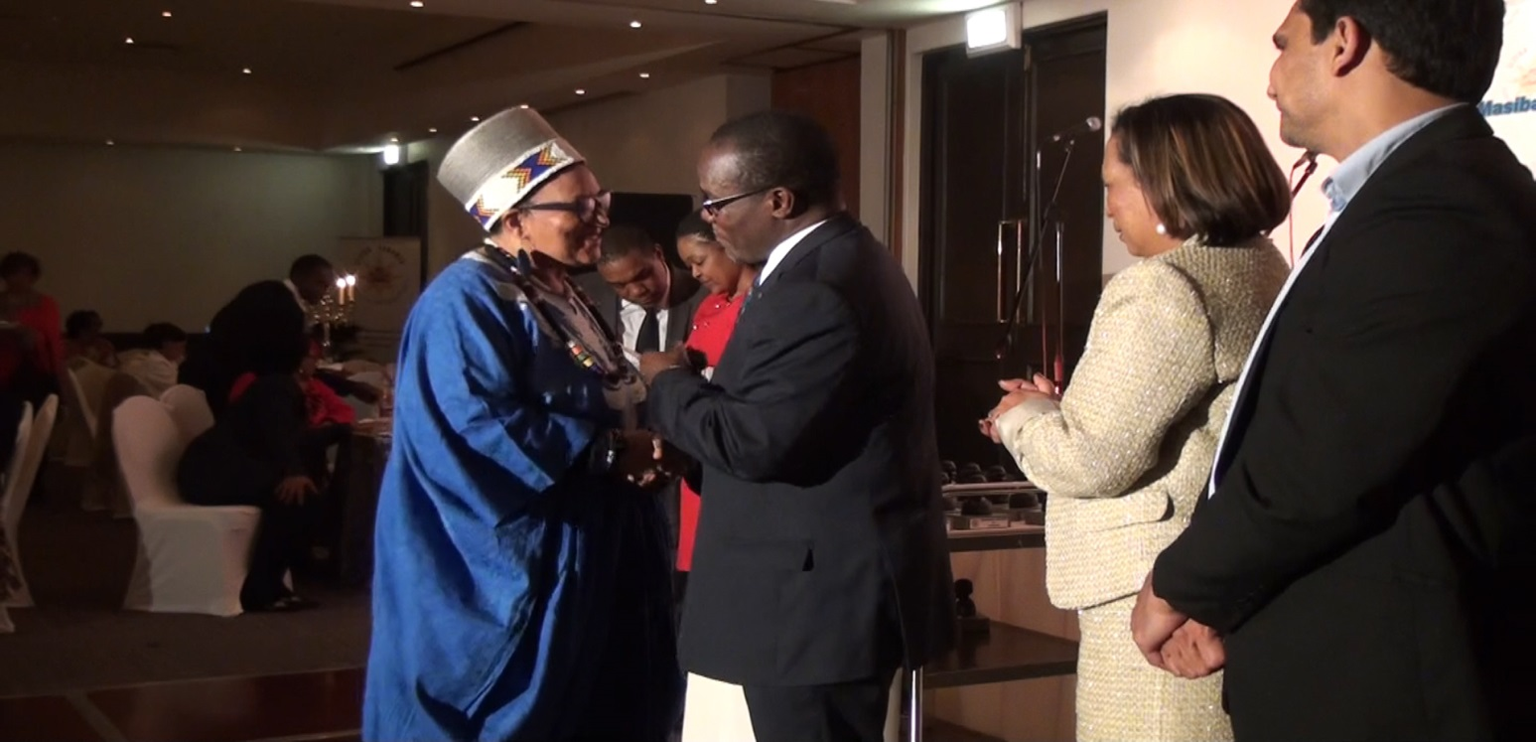

***Prof G Ferster Feminist (Kenya), Honourable C Wessah Presidency Liberia, Ms V Peterson CEO SASSA, Mr Z Dangor DSD National***

***Mr, Zane Dangor, from Department of Social Development***

Mr Dangor commented on the Commission of Social Development and the commission of the status of woman, however there is so many commission of There are many commissions and engagements, but what is concerning is that we are part of, however it is concerning, that when we address these concerns on an International level, there is often a belief that that human rights a “western inquisition” however the truth it is a result of European excesses, such as slavery, colonialism, racism, violence against children, wars, all of which occurred in Europe.

These were issues whereby human rights had to come in to place, to rectify the wrong doings from the European history, therefore representing the emergence of Africa in its struggle against colonialism and apartheid. However a lot of European countries have changed their laws within the past 40 years, however many of the laws in South Africa have not changed over the past 40 years, which leaves the critical issue of whether certain laws pertaining to the safety of woman, and gender equality need to be addressed.

***Premier Thandi Modise, Premier of North West***

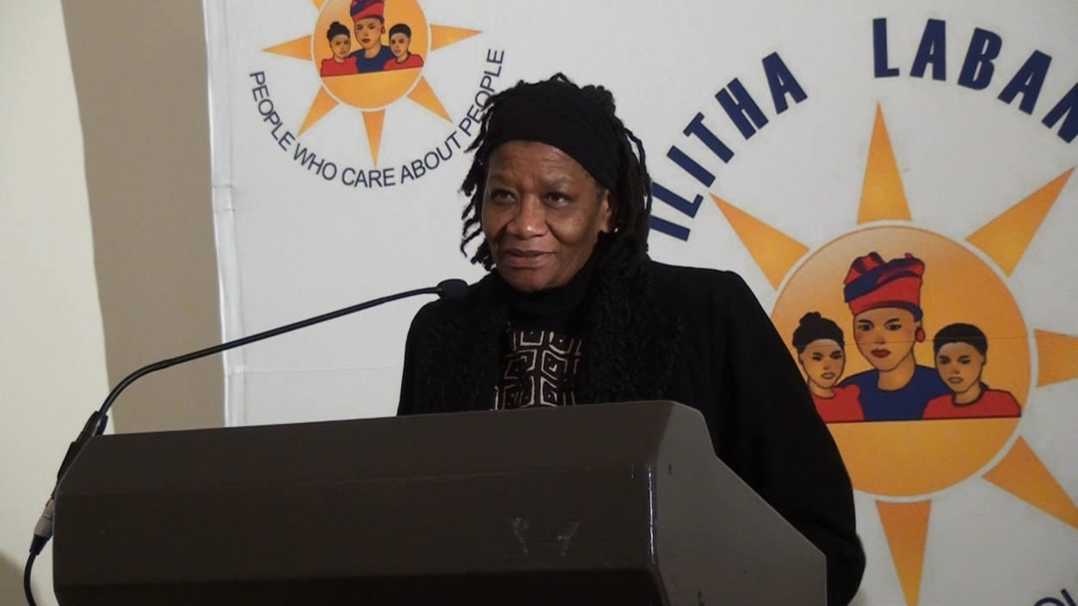

***Honourable Premier T Modise***

Ms Thandi Modise, stated that all of humanity is born with an entitlement to dignity and freedom, people deserve respect simply because they are human beings. She reiterated that people were taught from their childhood to have a sense of responsibility, to care, and attend to the wellbeing of other human beings, because we share the collective. We find nations are faced across the globe with the same common problems. Woman against their will get dragged into violence and partaking in violence, as well as becoming victims of violence.

Ms Thandi Modise further stated that, people have to further appreciate that woman were thrown out, and placed into a submissive role, historically and still presently. The fact is that we are not even close to reflecting the role of woman in South Africa. Therefore it must be accepted that violence against woman, is linked to levels of poverty that is occurring in society and that from this comes all kind of abuse, physical, emotional, psychological.

7 out of 10 women in South Africa have experienced violence in their life. In the United Nations Peace and Security Resolution of 1888 requests that Ban Ki Moon, appoints a special representative to appoint an executive to deal with these issues. After that resolution 1898, calls on resolution 1825.

Ms Thandi Modise stated that there is no denying that woman across the globe are working hard, and that woman have managed to push the most powerful structure on earth to look differently at what affects woman on globally. Woman asked in 1925, to be included in the peace mechanisms. Therefore it is imperative that woman need to look at the fact that we have forced the UN to recognize that our roles as woman is very distinct. The UN has not accepted the most recent resolution towards the safety and freedom of woman that was submitted, however woman must continue to fight towards better gender equality, against poverty and to collectively work to combat gender based violence and the effect of gender-based violence in the communities.

The long-term management post conflict management cannot be effective unless women are participating in these programs. Solutions cannot be found when you leave half of the world population outside. This means that it is up to woman, to make that voice loud, so that woman are able to sustain the resolution, in order to create global change. The resolution calls for all member states to prosecute perpetrators sexual crimes. It is critical that Woman are given the space to speak on conflict and peace on this continent.

As it stands we know that only 6% of woman have taken part in peace processes. Ms Thandi Modise, bought across the controversial and yet thought provoking statement “We must only blame woman, if we have failed to convince men, that this is not a man’s world. Therefore woman need to be in overdrive to ensure that there is stability, peace, security and development. Woman need to affirm themselves, and drag in all the men, those who are progressive, and pull them by the heels, those who are not progressive.”

By stating this, it is then realized that it is critical for woman to be in leadership, and in decision-making roles. As it stands, the threat, and the psychological stress of possible rape, has a grave effect on the woman, woman still to this day remain as the backbone to society. “Rape, is not just rape”. She further went on to explain that it has a grave and has dangerous emotional and psychological impact. It can then be understood that it is critical that this action starts at home. This starts with protecting and fighting of protections for all women, and for woman to become fundamentally pro-active in that role.

***Minister Conmany Wesseh Minister of State without Portfolio in the Presidency, Liberia:***

Women need to be seen as equals and to be given power. The president of Liberia was a leading example of woman in Liberia, emancipating them, despite the fact that she was a victim of sexual abuse. She rose above her circumstances and become and leader and is an example to all woman. This example extends to the whole of Africa, which created precedence for all women, to not be ashamed of themselves if they have been at the hands of violence. Women hold the responsibility of empowering the woman around them, to overcome serious challenges that are faced.

Minister Conmany Wesseh, also stated the importance of woman being seen as equals, and that this is one of the most critical and primary ways forward. Women are still being held back on all levels of society, and men have not yet completely shared the space from woman to be treated as equals. That as long as men deem themselves as superior, and for as long as men do not empower woman, then woman, and therefore the whole of society will then be held back as a result. For poverty to be eradicated, for economic development, woman must be empowered on every level. Socially, economically and spiritually, by their partners, who can then see and hold them as equals.

***Deputy Minister John Harold Jeffery of Ministry of Justice and Constitutional Development***

Deputy Minister John Harold Jeffery stated that in the recent statistics for the domestic violence protection order, the 2011-2012, rose by 34% to 246, 609 applications. This indicates a substantial increase, which shows the prevalent need for intervention from all levels of society. Deputy John Harold Jeffery has also stated that department of Justice and Constitutional Development has completed the draft of a prevention act, for before, during and after a violent attack. The prevention act contains special measures to protect woman and children with disabilities, and to prevent the grooming of child pornography, and mentally disabled people. It gives the right for schools and crèches to also investigate incidences of abuse.

The Prevention Act is will be acting as a catalyst for the following reasons:

* Offenders will be put on a national register, to make sure that they may not work with children, foster, or teach children
* Partnerships will be formed with religious churches, synagogues and mosques and other places of religious gathering, in order to inform citizens and advocate the Prevention Act
* There is particular focus on the prevention of human trafficking
* Cellphone service providers will be implementing actions to help victims
* There will be focused better court processes, which will support the victim, as well as specialists on the matters and will have training on the dynamics of sexual offences
* 57 regional courts, which will specialize in these matters.
* Police stations will be upgraded to provide better support
* The Minister of Justice, has started forming strategies to prevent crimes perpetrated against LGBT people
* The Prevention Act will also criminalize acts of violence against older persons

The Deputy Minister added, that even though there is extensive legal framework already in place, and legislations being put in place, that the biggest problem is creating a change in the hearts and minds of men. This came up as one of the key points continually in the conference, whereby the legal frameworks of South Africa is acknowledged, and whilst seeking to refine and improve the current legislations, a focus is needed for man to man advocacy on preventing gender based violence, as well as a significant shift in the mentality if those who abuse.

Whilst many people believe that the correct way for this to occur within the South African context, is for stricter sentencing, the other side of that still remains for woman to become pro-active in their role, of reporting all forms of violence against them, as well as woman becoming advocates for the sisters, mothers, daughter’s and aunts.

Therefore it is only through the advocacy of groups, organizations and forums focused in that area, that a greater outreach for the maximum impact to be achieved. It was also discussed significantly about the undoing of ancient and pre-dated beliefs, Such as beliefs pertaining that it is ‘natural for a man to beat up a woman in marriage’, or that ‘woman should be disciplined’ It is because of this, that the education of the letting go of these cultural beliefs is attained. This can only happen through NGO’s and government becoming pro-active in the education of men and woman, in the communities of all aspects of gender based violence.

***Minister Bathabile Dlamini, Minister of Social Development***

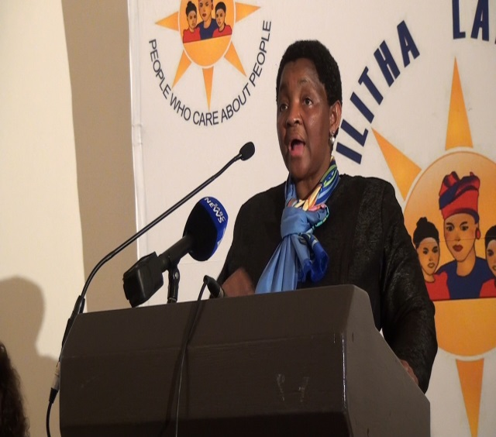Honourable Minister Dlamini stated that the children's act is very light; it does not protect children to the full extent. Minister Dlamini went on to explain that the way children are treated is a critical and fundamental part of creating a society where violence against woman, no longer exists. This was stated as mainly important for the reason being, that not only does parenting have a significant effect in influencing who a child will become one day. But that through instilling trust, that children will be able to open up to their parents, throughout all stages of their life, regarding potential violence of any sort. It is critical that the cycle of violence ends with the new generation and in doing that, the children are the primary hope for the future.

The Minister further elaborated that as we live in a patriarchal society, it is critical that woman are seen as equals. For this to happen, men need to be willing to share the power they have attained throughout the centuries, and to lessen the ego, when allowing a woman to make decisions. The Minister continued to state that woman should no longer be blamed for how they dress, and woman should not have to resort to humiliating methods to show how they were raped. (This was referring to many women citing that they had to show the posture and way in which the man raped them, and this is an unnecessary form of humiliation.)

Society needs to be conscientiotised. South Africans live in a society where we are not standing up strongly enough against injustice and violence against woman. We have become redundant, and as Ms Mandisa Monakali stated, woman need to continue to use their voices to fight against the greater injustices. Women have become guilty of hiding these crimes, for what is unspoken cannot be contested. What is not spoken, cannot be heard. What is not spoken, cannot change. Woman need to give up the fear of losing love, for standing up for the dignity of themselves and other woman, for society needs to create a society of woman who respect each other and are dignified in their approach to standing up against such violence.

Minister Dlamini went on to state that there are many critical issues that stand, such as the need for all shelters to be monitored and surveyed. The Western Cape currently has more than 50 designated shelters for woman. However the Minister fears that further abuse, sexual abuse or even human trafficking could operate under shelters if they are not properly monitored. Government, society and citizens need to strive towards protecting woman.

Another critical factor that is affecting and in fact creating the conditions for violence against woman is alcohol and substance abuse. It is critical that the banning of such is communicated on all levels. Women need to stand up against these issues. There are issues of drug trafficking and of woman becoming involved in such activates. This poses as a serious threat toward the stability of society. This brings back to point of why it is imperative that parents truly understand what is happening in the lives of their children. Absent parents, and parents who hide the abuse that is happening in their households are not only contributing toward the greater ills of society but are allowing such violence to continue.

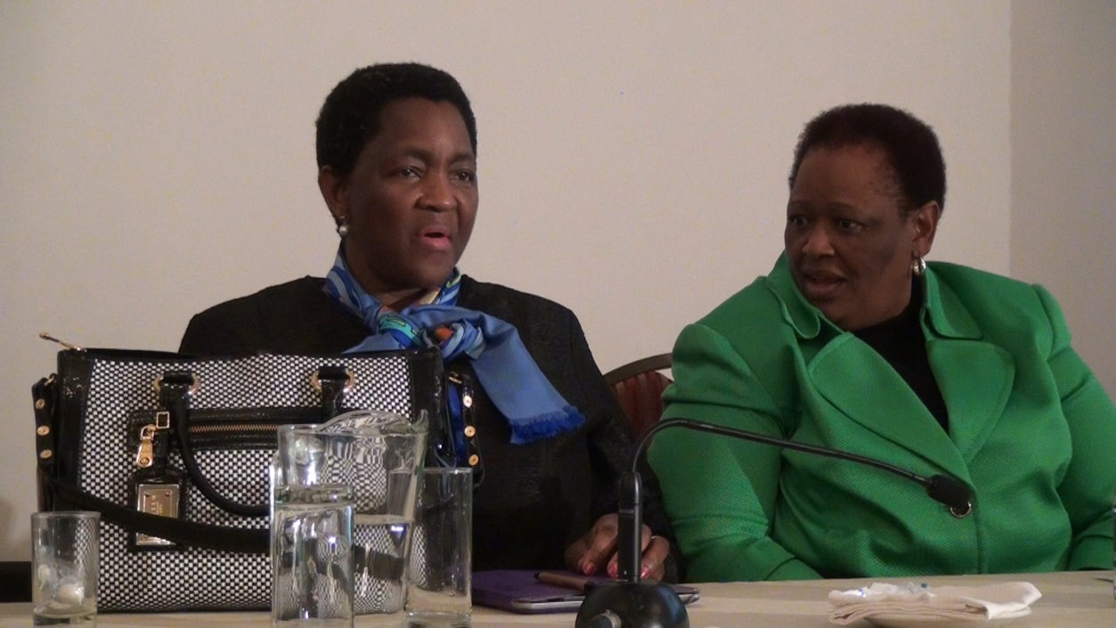

***Honourable Minister B Dlamini & Ms M Monakali AWIF / IL***

There are also an exceeding amount of cases, more than a quarter, whereby woman are withdrawing their cases from the court after they have reported a man for rape, often in the fear of their own reputation, or fear for upsetting their surrounding family, especially is a family member is involved.

Woman need to be able to release the social dogma’s associated with rape, and abuse, for the greater good of all women. This will be a pivotal turning point in society. The Minister stated that is vitally important that the norms and standards follow the law, and that also there are support systems in place. At present there are 102 shelters for woman, these are run by NGO’s. The government owns another 5 it should be asked why the government is not actively involved in creating more shelters, or in supporting the NGO’s that do run such shelters.

***Director Nolufefe Dwabayo, Ministry of Department of DIRCO***

With the legacy of the struggle that Ilitha Labantu emerges victorious, in helping woman and children. There is a need to redefine who we are, were we are going, what can be implemented at the end of the day we must create a nation that understands each other. We must not stagnate on the steps in helping each other, and working for the transformation of South Africa Peace and Security issues need to be re-addressed, as the role of woman is significant, as woman have a critical role in conflict resolution

The aim in 2010 claimed 2010-2020 ‘The Africans Woman's decade’. Therefore all women are called upon, to create critical change that is needed. Africa must be reminded that this decade is a decade that prides It’s self in the restoration Sexual violence and rape, South Africa has been assertive in implementing the UN code of conduct and the UN principals. This effort needs to be enhanced so that we can see the results of our efforts. The UN is recognizing the efforts of South African woman and organizations

***Inkosi Pathekile Holomisa - President of the Congress of Traditional Leaders of South Africa***

“People are using the excuse of ‘culture’ to say that it ok to violate woman and child. But this is only a cover, and is not accurate, because the African culture does not condone violence and rape of woman and children. They say, it is not the culture that does not fall in line with the law. However in the Xhosa culture, women have been taught the right to safety, security, dignity. A woman is entitled to a piece of land to grow food and to call a home. A woman has a right to and, and she should not be deprived us this. She is a wife, and is entitled to all the rights that the family enjoys.

A woman is then to be looked after and respected so that she may take care of the family and children. If a woman becomes a widow, she is still entitled to all the rights. *“A stick doesn’t hold a homestead” This shows that this is in no way does the Xhosa culture condone rape. The women are allowed to chase and beat the man who has raped. In the Xhosa culture, they are allowed to take the law into their own hands.”*

***Prof Alfred Nevhuthanda, Chairperson, National Lotteries Board***

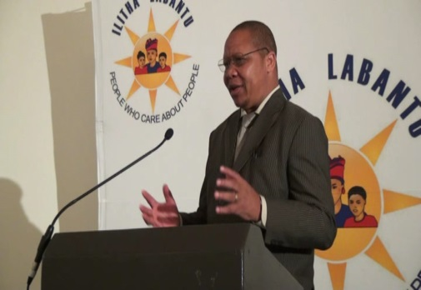

The National Lotteries Board is taking efforts to resolve the economic crisis against woman in society. Professor Alfred Nevunthanda, Chairperson of the national lotteries board spoke about the definite contribution of funding toward the national lotteries board. Professor Alfred Nevunthanda also spoke about the current funding to NGO’s that combat violence against woman, stating that a concerted effort should be made to prioritize organizations, that empower woman and that is important for the National Lotteries Board to remain focused on the emancipation of the woman. The National Lotteries board has planned to show adverts on how much money to apply for in accordance to the growth of the organization.

Professor Alfred Nevunthanda focused on this in particular, explaining to the various NGO representatives attending the conference how they can better their chances at obtaining funding for woman’s rights and gender equality. It was stated that as from next month, there would be new adverts to tell people which province the national lotteries will be visiting. In addition the National Lotteries board has decided that 50% of the funding must go to rural areas as they recognize that it is the rural areas in mostly in need of economic development. It is the dire poverty in rural areas that is the cause of gender-based violence.

***Dr Vuyelwa Nhalpo Chief Executive Director: National Development Agency***

Dr Vuyelwa spoke about the fact that the National Development Agency (NDA) has taken heed and has heard the voices of concern on the issue if violence against woman. The National Development Agency is fully conscious of the situation, of violence against woman. However the NDA states that there is immediate concern that the private, public and government sector are not talking about the current situation enough.

The acknowledge that with the high statistical rate of violence against woman that is currently occurring on a daily basis in South Africa, that the private sector as well as the public sector are not taking enough responsibility in combating violence against woman. The NDA understands that they private sector has contributed towards female issues, but at the pace of progression, it is insufficient to create the desired change amongst the communities.

The NDA spoke about the fact that it is critical that woman need to recognize that they are the pillars of society. Civil society needs to start need to start being selfless in the struggle for woman empowerment, as women are being abused day in day out. The NDA also spoke with great concern that to date, no funding proposals have been received regarding fun ding for causes combating violence against woman. This in itself shows the lack on commitment from all sectors. Although the policy framework has been a challenge, there have not been many studies that measure the impact of the work that has been done. If people are being funded, and if people are in positions of power, they need to be able to be accountable.

The NDA acknowledges that woman have natural skills that they have developed themselves through the ages, and are the backbone of daily, society and this country. It is the women who are the mothers, the wife’s and the breadwinners. Currently, policy framework is not saying much about prioritizing BEE, and other policies that allow the empowerment of woman. Therefore the NDA will continue to push hard to have the NGO sector capacitated. There is so much technology and resources available, hence the NDA says that it is critical for all sectors of society to become proactive in ending violence against woman, and utilize all resources that are available.

Every year there are budget speeches by national ministers, year after year after year. It is time that they are held accountable. It is only in these spaces that impact can be truly seen. If the government says 51% goes to NGO’s, then it is important to be asking from which NGO’s. If there were such things that were put in place to strengthens and mobilize civil society- we need to evaluate to what extend that has been done.

The suggestion was also put forward and that the constitution needs to be further utilized and further put into action.

***Mrs Mvuselelo Huni Chief Executive Office- ORAP- Zimbabwe***

Mrs Mvuselelo Huni spoke about the different kinds of poverty that occur today. The spiritual, mental, economic and social poverty. It is through the social, moral, mental and economic ills of society that can progress to greater stages of human fulfilment. Mrs Mvuselelo spoke about the economic system in Zimbabwe citing that whilst there has been no funding available, woman have managed to grow a billion dollar industry from self-motived enterprises, and through the means of working together and supporting each other. Through communication woman have joined in efforts in Zimbabwe with agriculture and commerce, creating business with no funding, but with absolute innovation. Mrs Huni advised that it is this kind of collaboration that South Africa should take inspiration from, and that a perception of entitlement or of victimhood will not help woman in emancipating themselves from gender inequality.

Culture is also critical for society, as it retains the moral fiber of society. South Africa should not seek to throw its cultures out of the window, but should rather aim and seek to develop cultures in a meaningful way that promotes a sustainable society.

It is possible for a society to be created in such a way by citizens that promotes that absolute upliftment of society. Mrs Huni then further went on to explain, that ultimately South Africa is in a stronger position, because there is grants and funding available. The tools are there, it is now just for the woman of society to utilize the fullest potential. At present South African citizens have access to numerous forms of funding, such as, SME’s funding, funding from government agencies, funding from NGO’s as well as Corporate Social Investment funding.

Mrs Huni also spoke about how critical it is for society to harness value for woman, and that ultimately there is no such thing as a working mother, because woman are always working, whether it be looking after their children and family, as well as their communities. Therefore woman need to value the resources available to support them in the role of creating social change. Women also need to understand that fundamental aspect that it is woman who can be the catalyst for change n gender equality. It is woman who must sand up to men, and it is woman who can utilize the resources and build South Africa into a better country.

***Mrs Pauls Assubuji, Human Rights Program Manager; Heinrich Bolls Foundation***

Mrs Assubuji started by sharing the role of the Heinrich Bolls Foundation, South Africa. She stated that the foundation focuses on the primary objectives of “ecology, democracy, gender democracy, solidarity and non-violence. Mrs Assubuji, spoke about the importance of connectivity amongst NGO’s that are focused on ending violence against woman. It is through the collaboration that NGO’s can support each other where needed, and can collectively work to present a stronger voice for woman. This is critical, not only to create the change that is needed, but for woman to also understand how they can further empower other woman, and society.

Woman must be able to debate, criticize and discuss these critical issues collectively, as this allows for the formation of new thinking, new emerging ideas and innovative action. It is through the interconnectivity that woman will strengthen their ability to stand up against such social ills.

Woman’s voices need to be heard. Mrs Assubuji, posed the question of why at present woman’s voices are not being heard and why woman are not standing up for each other and for each other’s rights. As long as the conditions of a patriarchal society exist, then it is imperative that such social ills will continue. Woman must not be the victims, but rather the victors, by collectively standing against each and every perpetrator, and through collectively standing against violence against woman. Until woman are able to stand up, solely and collectively. It is critical for South Africa at this stage in time, for woman to collectively stand together in solidarity.

***Mr Mbuyisiselo Botha, Government and Media Relation Manager of Sonke Gender Justice***

Mr Mbuyisiselo Botha, spoke in depth about the role of man in combating violence against woman. Men play an important role and factor in gender equality and therefore it is critical that mean are able to recognize their roles in the creation of gender equality. Men need to acknowledge and take responsibility that men perpetrate the violence in this country against woman. Single mothers raise majority of men in South Africa and although fathers are present they are often absent. This causes many problems, not only in the connecting and understanding of their family, but also in development of their children.

It is acknowledged that to date many men are the breadwinners of their family, however they should not shy away from the responsibility they have toward their family’s emotional wellbeing. Men often do not understand that money is not ‘the be all and end all’- and for society to change they need to start to recognize their roles within the family. Men have always been taught to lead and be in control, however men must no longer feel insecure and threatened. It is important for us to say that men cannot do this work without the support of woman's organizations. Woman need to look at how we can support men in this understanding of gender equality, and support men in the transferring of power

Currently the economic situation in South Africa allows violence to continue. Although men and woman contribute economically, all symptoms of the ills of society need to be addresses with utmost urgency. Violence against woman is society’s ill in the bigger picture, however until men are able and willing to share their power with woman, and view woman as equals, this will not be possible. It is critical that men re-instate their involvement with family matters, that they partake in the upbringing of children, and that they also understand their pivotal role in society.

***Ms Litha Musyimi-Ogana, AU Gender Director***

Ms Litha Musiyimi Ogana spoke about the importance of the emancipation of woman. As Ms Ogana has stated previously: “The AU is committed to gender equality and women’s empowerment. The AU has clearly demonstrated this commitment by providing for gender equality and women’s empowerment in the Constitutive Act, Adopting the Protocol to the African Charter on Human and Peoples’ Rights to the Rights of Women in Africa, Solemn Declaration on Gender Equality in Africa, the AU Gender Policy and the declaration of 2010-2020 as African Women Decade and creating as well as financing the Fund for African Women.”

Ms Litha Musiyimi Ogana, also stated the procedures in place for the procurement of funding from organizations. As present several issues have presented themselves in in the attaining of such funding. At present most proposals are sometimes up to 79 pages long. This can be extremely problematic and off-putting for potential organizations. This needs to be addressed as to why organizations are having to work so hard and provide so much evidence of what they are doing, to just file an application let alone to attain funding. It is acknowledged that if an organization is sufficient enough in the practice of the organization, then the funding should not be such a difficult process.

The funding for organizations that support the ending of violence against woman is available, so it is imperative that these processes are made easier for the obtaining of such funding to benefit the whole of society.

***Mr Phillip Mgomezulu, on the important role played by civil society on ending violence against woman.***

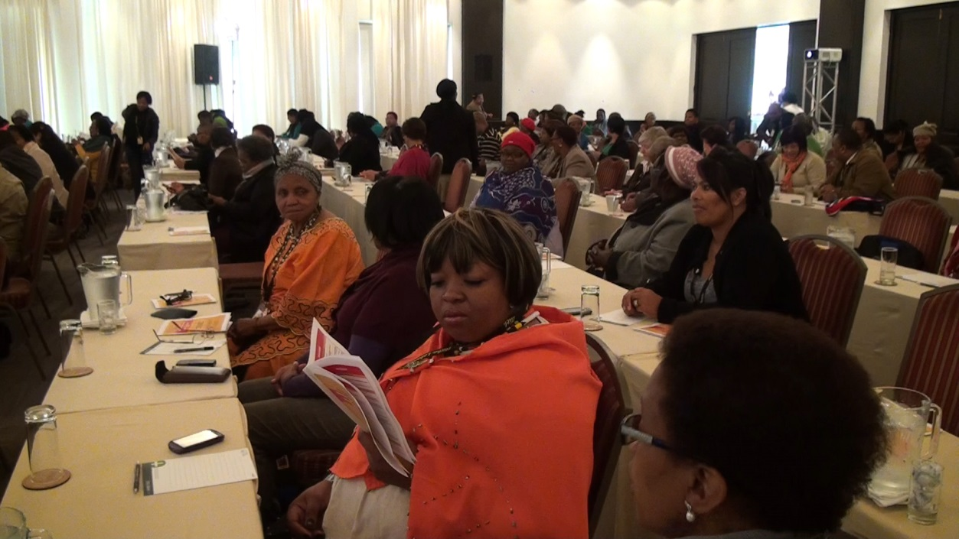

***Delegates from KZN & Northern Cape***

There are many levels of society that can be addressed in the ending of violence against woman. It is important that by standers of violence take on the responsibility of reporting and informing of people they know regarding the fight of ending violence against woman. By standers have a responsibility whereby if they are silent, they are silently accepting the injustice that they have witnessed? It is the bystanders who also hold a large degree of power in creating a South Africa of gender equality and justice. By standers are witnesses to some of the most violent crimes, and therefore have the ability in their decisions, that will determine whether the perpetrator in convicted or not.

By standers see the result, know the assault will happen, and they are able to get help for those who are victimized. Each and every person has at some point been by standers. People need to start understanding their role as by standers, instead of taking a passive role. There is this passive role that is extremely damaging to society.

A situation can change entirely with the support and the by-stander reporting what they have seen. Sometimes by standers are fortunate whereby they do not know the perpetrator, which in that case, makes it only a basic human responsibility to report the crime.

The girl-child's is very vulnerable, and it is the youth that needs protection and support. Innovative ways need to be created; in preventions can be put in place that will protect the boy child's, as they are very susceptible to substance abuse- which later in their life, affects woman as well. The boy child’s are the men are the future, and in that respect, it is critical that society and parents are able to raise the boy child’s in such a way that they have a strong value system and inherent respect for all women.

Society needs to focus on building strong families, and to bring back the spirit of Ubuntu. It takes a village to raise a child. There needs to be community gathering, sports event, and more religious platforms in order to create such support. Through the past five decades the morality of society has become worse in many cases, and in that doing, so has the breakdown if the family unit. It is important that society is able to recognize that, and work on the preserving and enrichment as well; as support for the family unit. It is through strong families bound together by morality and respect that society will change for the better.

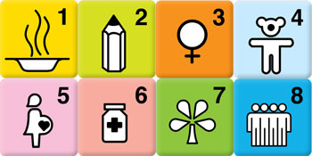***Mr Desmond Booyson - Executive Manager- STATSSA, on the statistical analysis of the present situation in South Africa.***

* **MDG Goal 1:**

Core Problem: The stats still show and proof that there is grave financial inequality in South Africa

* **MDG Goal 2:**

Core Problem: There has been a significant increase in education, and the results from education, with lowest performances still on mathematics and science

* **MDG Goal 3:**

Core Problem: Woman are still earning significantly less than men, there is still a huge disparity in that regards

* **MDG Goal 4:**

Core Problem: There has been an upward trend in child mortality, there is also lower levels of pneumonia

* **MDG Goal 5:**

Core Problem: There are no defined estimates, as this has not yet been established, however, there is a slight decreased/decline in the maternal mortality rate

* **MDG Goal 6:**

Core Problem: HIV/AIDS, Malaria and other diseases has significantly increased, with the largest age group being 30-39

* **MDG Goal 7:**

Core Problem: Carbon emissions have been increases radically, and so show no positive results

* **MDG Goal 8:**

Core Problem: Global Partnerships- there has been a dramatic increase in trends in the GDP per capita

***Ms Yandisa Mpetsheni, Statistics South Africa-Gender Report***

Stats SA also explained the following STATS to the attendees of the conference, regarding the status quo of woman in Southern Africa in the context of ending violence against woman:

**Figure 1**



Figure 1 shows a clear indication that at present, 3.8% of girls aged between the age of 10-19 years old are married and living with their partner, as opposed to the 2.2 of males. This indicates that at a young age woman are getting married, and therefore we can see that it is likely that they will have limited access to resources, such as a stable income, or have a career established. This is a strong indicator that the young woman who are married, stand at great risk. However we see that as the age increases there is a large amount of woman that are not married and are living as single mothers.

The rate of single motherhood is on the increase, hence the need for the support of the family unit, and support for single mothers. This is critical in providing the woman the support they need, as these figures increase, as they get older.

The question of single motherhood can only be attributed to the breakdown in the family unit, whereby, either the father was never actively involved from the start, or the young woman separated from her partner. It is then evident, that this highlights the importance of men being actively involved in the family, and also in taking responsibility for the families that they have created.

**Figure two:**



Figure two shows the percentages of the different racial groups that are cohabiting with their husband or wife. This shows that Black African woman and men are less likely to have partners living in their household. Over 25% of black African woman are not living with their partners.

This brings into immediate question is to whether this can be attributed to the fact that the most of the black population living in rural areas, therefore being affected much more economically. It should also then be in question of whether it is the violent crimes are reported if this figure would increase, but more so as a positive result of the woman no longer living with the men who are perpetrating the crimes.

However, there can be no doubt, that in fact there is a higher rate of separation amongst couples in the black population, which may be attributed to the poverty, and the living in rural areas as an effect of apartheid. It is therefore seen why it is so critical for the empowerment of woman, as well as black economic empowerment in South Africa, and gender based violence and poverty is strongly linked.

**Figure 3:**



Figure 3 shows us the percentage of children living in households where only the mother is present. 41.9% of black African children are living with only a mother present. This means that four out of ten African children are living with their mothers only. This represents and indicates the core need for support, woman empowerment and the ending of violence against woman. If almost half of the black population is of single mothers, or children living with single mothers, it is then evident that perhaps greater support from the government is needed, in providing financial resources and support for the single mothers. It is also the combined factors, that was discussed at the conference, that show that ultimately, it is also important that mothers collaborate with each other, and that they rely on each other for resources and mutual support. This is why the advancement in the ending of violence against woman, is dependent also, on the ability of woman to speak up, and report abuse.

**Figure 4:**



Figure 4 indicates the percentage of parents that have access to childcare per a racial group. The figure clearly indicates that only 34.6 percent of black African parents and access to childcare compared to 62.2 percent of white households. There is cannot be questioned that indeed woman in rural areas, are facing serious challenges, as this figure is almost half. For woman to emerge from poverty, many are faced with the challenge, of trying to get a job yet not having childcare available. It should be questioned as to whether more childcare facilities and support is needed, for mothers, so that they are able to empower themselves with jobs, and a career.

**Figure 5:**



Figure 5 shows the percentage of men and woman living in households were dung or wood is used for cooking, as opposed to electric appliances. The figures show that for black Africans the percentage is 20.8% as opposed to the 0.4 % in white households. This still shows the effects of poverty caused by apartheid and how this is affecting gender equality in South Africa today. It must be taken into consideration that those living in rural areas are facing greater challenges than those living in the established urban areas. For someone living in a community, it is evident that they need to walk far distances to get water, wood and dung, and often face challenges of not have hot water and sanitary access. This level of poverty is a great psychological stressor.

**Figure 6:**



Figure 6 shows woman and men aged 18 and older who have access to medical aid. There is a significant difference in the percentages that have access to health care. Only 7.5% of black females have access to healthcare as opposed to 70.7% of white females. It can be seen how health has a serious impact of the development of a healthy family and home. With greatly increased prices of medicine, it often means that those living in townships are suffering from serious health problems, without access to adequate care. If a woman is abused by her partner, it can become very likely that the victim will not have access to transport, health care, counselling or child care. Hence the severity of the crises remains immanent.

**Figure 7**



Figure 7 shows a comparison of the educational levels between men and woman. Whereas 36.6% of women have had no schooling, 66.6 % of Men have completed Matric. This shows the gender disparity that is occurring within South Africa. Due to lack of education woman are unable to find jobs, and become breadwinners of the family, being able to provide their own economic support. The lack of education available for woman in impoverished areas, who may not be able to afford education, leaves the woman in a situation where she is then dependent on a man. It is in this that many women become trapped in abusive relationships, unable to emancipate themselves due to financial difficulties that result in a lack of education.

**Figure 8**



Figure 8 shows the unemployment rate of woman compared to men. It is seen that consistently with all races, woman face a higher unemployment rate with men.

As it can be seen through the statistical data, that poverty in South Africa is still immanent with majority of black woman, not having access to income, stability, education or medical aid. With the additional fact that most women at present are single mothers, this shows the crises at hand.

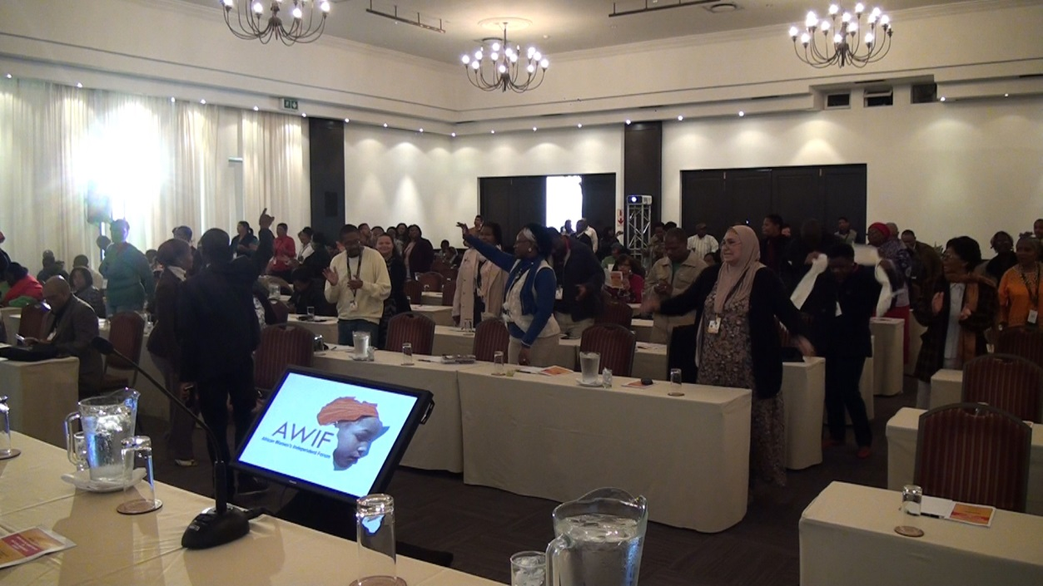

***Delegates united in song***

***Professor Gertude Fester, Former Member of Parliament, Activist, and Poet Commissioner***

Professor Gertrude Fester spoke about the fact that there is this perception that it is the boy-child’s who are often left behind. However, in terms of the bigger picture and understanding, it is also the girl child’s who are left behind from infancy to University. These findings are supported by the United Nations. As stated by the head of UNICEF “Around the world, too many children were being left behind, due to poverty, malnutrition and “unpardonable” discrimination”. The advancement of woman remains as absolutely essential to the progress of society.

As it stands, women are no longer confident in the Justice system, and are no longer reporting on rapes. It is the woman in South Africa who are most necessitous to the need of having a system of safety and a justice system that will hold each and every perpetrator of domestic violence accountable. It remains equally important that the family is able to support the woman who finds herself going through such a painful and difficult process.

Professor Gertrude Fester also stated the importance of more engagement with woman NGO’s. More out of the box solutions are needed, as well as creative and constructive ways for solutions come into action that will greatly benefit all of those who are involved. It is not a question of capacity, and it is not a question of the current infrastructure that is already in place in terms of laws and legislations, but rather, it is a question of the implementation of action to solve these problems that affect the lives of the woman today. It is critical that we are able to learn from international best practice.

***Ms Mandisa Monakali, founder of AWIF, on the role that AWIF in sustain the Women’s Movement in Africa:***

“AWIF was founded in 2006, and it was launched at the United Nations, it was formed because we realized why we have the United Nations and other International structures, but the voices of African woman are not there. I am the founder of this organization. With AWIF, we don’t say “I” we say “we”. “AWIF is made of individuals, it is a membership organization. Although it’s formed through and by individuals, and organizations, networks and decision making bodies, it was formed as one of the issues that made us form AWIF- was to develop and design processes that empower woman on all levels. People speak of the MDG’s. In the year 2000, it was a giant idea, people did not want to talk about it. Parliament did not want to discuss it. Each year the president says by 2014 we will do 1234 (steps that are required), and by 2015, we will have reached our targets, SA is a signatory of those Goals. It is critical especially in Africa.

In 2005, the UN rejected our report, because the voices of the masses were not there. In 2009 we realized that we are supposed to report. This means that this was only realized 9 years later. When we were told that South Africans had to report - we realized the country was in crisis. Workshops were conducted in 9 provinces. In 2010 the report was then accepted. The MDG’s compliment the process for African development. It is working hand in hand with the people. We promote much needed partnerships with government and civil society. Even our reports in parliament- everything has to be backed by the voice of civil society. We think money buys everything – but to get the resources, we need knowledge. Another thing would the formation of partnerships. Woman realized that it is important to reduce poverty. Section 1325- is one of the most important resolutions. We are a part of the United Nations Council - this is crucial for security and peace keeping. People may not get information from the Premier- however what is happening is a critical tool, and we need to realize this resolution.

The UN women’s right protocol- this is also critical as well as the Maputo declaration. The majority of woman in Africa are still facing extreme poverty. They say there is no funding, no information. Do you know how much information you have around yourself? This is why AWIF was formed. As a country we are so aloof. Exposure is very important. Once we have exposure then you understand. If we want to resolve poverty- then we need exposure. If you want to know what poverty is, then look at Zimbabwe, however why are we not partnering with our neighbouring countries?

The African protocol on the rights of woman is a framework to guarantee the rights of woman. We are not utilizing different methods so there needs to be extensive research. AWIF was formed on the realization that we need to localize on all these issues. With the MDG’s- this was a civil society effort.

When we look at other countries who have other issues, we start looking around and saying where are we as South Africans. In those environments it is not easy. We must push for what is positive. The vision of AWIF, is to seek to consolidate, multi-dimensional thinking, and activism, for woman to openly express their views. The mission of AWIF is to build the woman through activism, through promoting for responsibility and political freedom. We also aim to achieve our goals through an African woman’s perspective- and on working on changing social and cultural biases.

One of the objectives of AWIF is that we still have a long way to go for research. How many researchers do we have in South Africa? How many woman researchers do we have? We need to promote young woman as researchers. Why are we not promoting woman to be researchers? Why are we not promoting our educating them? This is critical.

That is the purpose that AWIF was formed, so that we can promote that. That is critical. We need to bring in participatory research. Also, there is information for AWIF is available. We need to also look at AWIF must be an information hub, whoever wants information can get information. Not everyone has a computer or internet- but whatever information is needed must be available from AWIF. This is critical- to say that yes this is there. We must check what is happening on violence against woman.

We need AWIF work, through researchers- so that people can provide information. We need to know how many funders there are, and how many promoters there are. This is critical. We must see how to get this information. AWIF will provide the opportunity for women to dialogue amongst themselves. The research must be available to all women and all those who cannot, can have access to information. There must also be an online resource center. We need to re-evaluate African woman's roles. There must be research, and there must be accessible research for all people. This is critical. We need to be a watchdog for woman policies that are implemented.

In South Africa our biggest problem is implementation. AWIF will make it a critical role, that this becomes implemented. AWIF is an International partnership. It is there for woman and a platform for woman to utilize and use.”

***Recommendations from the Panel Discussions:***

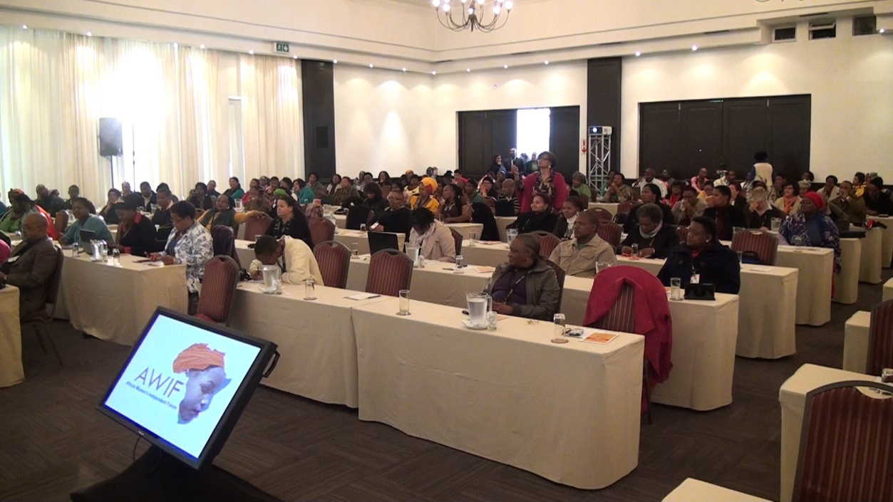

*Input from the floor*

**The following are the key points that were established through the panel discussions:**

* In terms of sexual health and reproductive rights- South Africa does not yet have strict enough or thorough enough procedures in place for preventative measures.
* There must be a charter protecting the girl-child. The issue of holistic care for an individual must be addressed.
* Deprivation of knowledge on its own is violence. There is also emotional violence. The unethical behavior of officials violates the rights of woman. We need to ask ourselves who is under the most stress in the country. Each and every person’s dignity and rights needs to be respected.
* Men must be liberated so they are not suppressed, and so they feel safe to emancipate their woman.
* These statistics belong to us- and the public health, how do we create action when we are not aware of the knowledge of how people are dying, and what is causing death in childbearing woman. For example certain departments have not been able to produce statistics due to the lack of reporting from woman of cases of domestic violence. In other cases reporting is not done, as they have not come up with the methodology to do so.
* The HIV positive people go to the clinic too late for it to be cured or for it to be treated. More clinics and access to these services is needed, for the lives of woman to be saved.
* There is the issue of the violation of rights, after a woman has been given birth, then the woman can become mentally ill, if she does not have the right care and support around her. As many women are victims of domestic violence, it is then vitally important that they get the care and attention as needed.
* There should be things done around forensics- there needs to be more evidence for woman.
* There needs to be conclusive evidence- as this will be challenged in court. Currently women are not aware, as well as SAPS of the importance of clinical evidence in court. It is through this oversight, that many perpetrators and cases cannot be pursued in court, due to the fact that there is no proof.
* There should be no violations of confidentiality. Women are worried that their partners or communities will find out about the abuse that they have had to ensure, or that there case of assault will become public. For some women, this may put them off reporting the perpetrator.
* National Health Insurance- needs to cover woman for all issues. At present it does not cover critical issues that arise when a women has been raped or assaulted. The government needs to become accountable in providing woman with better health care, and access to services.
* If you are a pregnant disabled woman- there is great humiliation- they will ask- how can you manage to have a baby, how you handle this child. This needs to be addressed. Although there are programs to help women with disabilities, more needs to be done to ensure that women with disabilities get the attention and health care that is needed, without having to endure any humiliation.

***Ms Noxolo Nakani, Social Worker at Ilitha Labantu,***

Ms Nakani spoke of the programs at Ilitha Labantu stated that there are currently five departments at Ilitha Labantu working to combat Violence against women. There are:

1. Clinical Apartment
2. Assessment
3. Education and Outreach
4. Research
5. Advocacy and Law

With all of these departments, this the structural base of the organization helping woman and children.

***Ms Masunha, Director of Musasa project, Zimbabwe,***

The representative and International guest of AWIF & Ilitha Labantu spoke about the local, provincial and national issues summarizing that the building of partnerships is critical, with organizations, with churches, and in doing so involving men in the process of woman empowerment. The many entrepreneurship projects in Zimbabwe run by woman who have not had access to funding, is a primary example of how this is possible for woman in South Africa, with the added advantage that in South Africa, woman have the power to create economic emancipation, and to emancipate themselves from the grip of poverty.

Woman organizations have the power to change the status quo of the country, and need to be given a chance to build capacity for the empowerment of woman.

***Closing Remarks and Core Issues of Discussion***

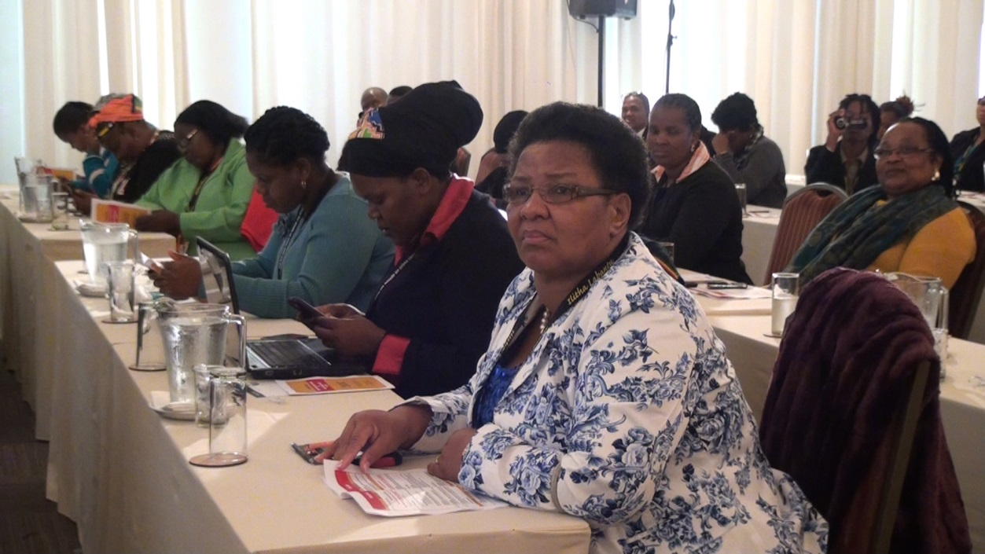

*Delegates from Eastern Cape*

***Key points were discussed, which hinder gender equality and woman empowerment:***

1. **Poverty**

Research has shown that poverty is more prevalent in female-headed households. Studies show that female headed households have a chance of being 60% in poverty, whereas male headed households tend to be 30% in poverty. Also that unemployment is significantly higher for woman than it is for men. Up to 30% of women are unemployed compared to only 30% of men. Other studies have also shown the direct link between poverty and gender inequality, For example, the 2013 crime statistics show that crime is most prevalent in impoverished areas. Stats SA confirmed that more than 34% of crimes are against woman. That is one third of crime in Southern Africa.

1. **Lack of support and economic empowerment**

Currently rural woman are marginalised, and woman are still globally facing gender equality in the workspace. It is found that even if first world countries, woman are still earning less for the same on than their male counterparts, despite the fact that most woman are working, raising children, and looking after the household. This brings serious questions into action, such as why woman are still being kept as ‘subservient’ and how woman can emancipate them from such injustice. Challenges that women faces were also discussed; such as women do not knowing how to start businesses, and the red tape that continues to marginalize woman trying to become self-sufficient.

* 1. **Education**

Most women in rural areas still do not have access to education. Stats SA stated that there is a significant gap in the learning development between boys and girls of core subjects such as maths and science. At present “115 million school aged children from South Asia and Sub Saharan Africa have not been educated with 56% of that being girls.” In South Africa, the number if students passing maths and science and therefore gaining entrance to university is 2.7%. The education is further suffered from various factors such as poverty in schools (schools lacking adequate resources), low teacher morale, and chronic diseases such as HIV/AIDS and TB.

As it stands, there is also a significant difference showing that a much higher percentage of children in rural areas lack education than those in wealthy areas. This is especially a problem amongst the black community, which indicated once again why black economic empowerment is so critical.

* 1. **Patriarchy**

Women still live in a patriarchal society. This means those women are still not regarded as equals despite the decades of work of woman fighting for equality. This fight must not stop. “According to Millett, Patriarchy’s chief institution is the family and many other radical feminists have agreed that, contrary to the assumptions of conventional political theory, the family is indeed a central part of society’s power structure, as it both sustains patriarchal power in the public world and is itself a source of women’s oppression.

Far from being a natural arrangement or individual choice based on mutual love and respect in which the emotional, sexual and domestic needs of adult partners are met and their children cared for, it is a social institution in which women’s labour is exploited, male sexual power may be violently expressed and oppressive gender identities and modes of behaviour are learned.” (Commission for Gender Equality) The issue of Patriarchy continues, as men need to re-educate in sharing their power with woman, and in empowering woman significantly.

* 1. **Unclear processes and success in reported cases of violence against woman**

Even though South Africa has strong legislations, prevention acts and laws in place, it seems that woman are either unaware of this, and woman are also not educated on the critical procedures to follow when violence occurs. It is also on the other hand, that woman should also be educated about this. For example, if a woman is raped and doesn’t obtain an immediate DNA swab/test, and takes shower or bath within 24 hours without doing so, then there is no evidence for the police to press charges. Woman need to understand that it is critical actions such as that and need to be educated, so that if the SAPS fails, or if someone fails to inform them at the time of the occurrence of violence that they are able to be proactive in obtaining a solution.

* 1. **Failure to report such crimes**

Women are also unaware that they stand as protected by law, and often fear that they will not win the case. As it stands, the South African Police Service reported that out of every 237 rapes, only 1 criminal is convicted. Every year there is approximately 23,000.00 rapes. That means that per 23,000.00, only 97 of the 23,000.00 perpetrators will go to jail. It is also said that almost a third of rape cases of withdrawn afterwards.

* 1. **Social stigma’s and fears of judgment**

As it stands it is reported by social services that more than a third of violence against woman cases are withdrawn. This is due to social stigmas and embarrassment. These social ills need to be combated, as they significantly reduce the chances of a rapist or abusive man being convicted, in which, also causes such crimes to continue against other woman. There is especially stigma if the woman’s family member is involved. Therefore women need to hold themselves responsible for the reporting of such heinous crimes.

* 1. **Culture:**

It was noted by many individuals of African culture that if you look at the ancient roots of the African culture, there was never anything written or condoned on a formal platform condoning the violence against woman. Therefore it can be noted, that it is through heresy and cultural development that this was seen, and is still seen, to be a part of the African culture. However a closer look at the history shows that these are myths that were formulated and become thought of as culture, and yet was never formally or historically a part of prescribed culture.

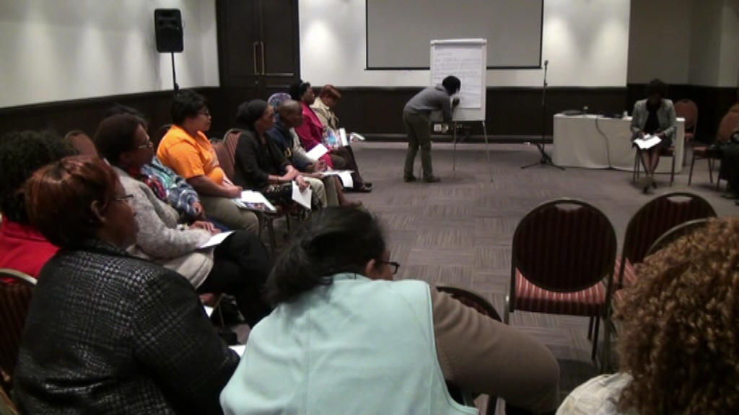

***Group Discussions***

The issue of gender equality and ending violence against woman has been on the global agenda of the United Nations, and Ilitha Labantu has taken the privilege to represent South Africa in this cause, being a voice to woman. As stated by Nguyen Cam Linh at the United Nations conference, it was said: “gender equality was smart economics.  Women’s participation in the labour force and earnings were associated with reduced poverty and faster economic growth, benefiting children and society as a whole.  Gender mainstreaming also continued to be one of the most effective measures for attaining gender equality; once implemented, it would help ensure that women’s needs and priorities were better met, social benefits were distributed fairly and women’s empowerment was no longer just a watchword.

National laws and policies that targeted the root causes of gender gaps were essential, but to ensure sustainable progress, the international community had to provide timely and necessary financial resources, technical assistance and share best practices.” In addition it has also been shown by the United Nations that the majority of the world population that is living in extreme poverty, is woman. The investment into the wellbeing of woman will have a direct impact on the alleviation of poverty, and the economic growth of South Africa. Women need to be equal partners in the process of economic development.

This report acts defines the outcomes, findings and intellectual strategizing of how violence against woman can be eradicated.  The SADC Protocol on Gender and Development called on half Africa to half gender based violence by 2015. At the summit, it was discussed in great depth of the attainability of this, with practical implications evaluating and checking the statistics throughout. Stats SA showed that gender based violent in more prevalent in rural areas, showing the direct link between gender-based violence and poverty.

The link between gender based violence in rural areas was discussed extensively, as well as the role of the South African Police service, different government legislations, discussions surrounding which policies are in place, as well as other various factors contributing to gender based violence, such as; the role of men in ending violence against woman, advancement of different policies, and woman empowerment.

More than half of the world’s population is composed of woman, of which global statistics say the current global situation is currently standing between 7 women to a man. This shows the great and universal urgency for violence against woman to stop. The occurrences of gender based violence has been increasing, and yet at the same time South Africa has and is implementing further steps to end violence against woman; gender based violence, as well as femicide.

It was agreed the a critical shift in consciousness is required for this to happen, as the global reports indicate that this situation is not unique to South Africa, but rather is a global problem that we are faced with. Globally, our international civil citizens stand at the edge of a food, financial, economic and social crises. This shows that is imperative that society contuse to work towards the true liberation of woman; the safety and protection of our daughter, mothers, sisters, and friends. The role of woman in the up-liftment of society continues to this day to be a pivotal role, as women manage families, give birth to our future citizens, and contribute towards the changes in the country and the economy.

For many of the speakers, it was acknowledged that South Africa has outstanding legislations in place, protecting the rights of woman, such as:

* Progressive Constitution, clause 9, assures us of the promotion of equality
* It is elaborated 17 times throughout the South African constitution, against discrimination, and 5 places in which gender equality is affirmed as critical
* Gender Policy Framework on Women’s Empowerment and Gender Equality
* In 2009 the new ministry for woman was established giving a woman within South Africa a definitive voice.
* The National Development Plan

South Africa further stands in line with International laws that give protection to each person, these can be defined as three laws, which provide the framework and foundation for all other laws regarding the evolution and development of human rights, and importantly gender equality and ending violence against woman.

These Primary Universal Laws:

1. Universal declaration of human rights
2. Covenant on the rights of a child
3. Convention on the elimination of all forms of discrimination against woman.

These laws provide South Africans, with the valuable opportunity in which to act upon the legislations and laws which have been put in place by the government. The entire framework is there, and so what is remaining, is the critical issue of implementation, and bringing these laws into full action.

As mentioned in the employment Equity Commissions (EEC) 10th annual report, the gender base violence in rural areas continues to persists due to the fact that femicide as well as gender based violence has a direct link that woman have to violence which is fuelled by the lack of access to economic opportunities for woman. Such as attaining financing for land, non-access to education, lack of support services, for the amount of woman who are suffering from gender based violence, as well as gender discrimination within civil society.

National statistics have shown the need for further intervention in ending gender-based violence.

The statistics indicate:

* One out of two woman will be raped or abused in their lifetime
* A woman is raped every 26 seconds within South Africa
* A murder occurs once per an hour in South Africa

This therefore indicates, that unless more serious intervention is implanted within South Africa, then such gender-based violence will continue. The summit also concluded that in an effort to reach and create change for most woman, in ending violence against woman, that more woman activism groups are needed, more awareness is needed, as well as critical training for men, to understand there fundamental role in ending violence against woman. Whether they are or are not the perpetrators in a domestic situation, it is understood that men have the power to speak to, inspire, coach and mentor other men, as well as report violence that they know of.

There were many critical issues and concerns that arose in the conference, some of that being;

* There needs to be more information on the cases of femicide
* The Police needs to be more specific about domestic violence, and not just label it as assault
* There needs to be more focus on woman in rural areas
* The issue of sign language- which often disabled woman are needing
* There needs to be communication methods available for deaf people, and for intellectually impaired people. Both deaf and intellectual impaired peoples are unable to report rape, and they need attention and assistance from the government
* Rural woman need to stop being under-mined. Woman in South Africa have skills, expertise and knowledge that needs to be acknowledged and utilize

1. **Gender equality**

Gender equality has been listed as one of the Millennium Development Goals. Gender equality and the empowerment of woman, is essential to the achievement of all other Millennium Development Goals. The positive aspects are significant, has global by-in, they are measurable, and allow South Africa to focus on such achievement, however there are certain issues that are not currently recognized by the Millennium Development Goals process. Gender equality is however important, and it is the responsibility of South Africa to bring to light the issues that are affecting the progression of the Millennium Development Goal of gender equality.

There are key indicators that will determine the success of the progression of gender equality. Research by Kate Pickett, and Richard Wilkenson, showed the importance of gender equity. Their research show that that is not just the improvised that suffer from an unequal society, but it is everyone that suffers as the effects of gender equality are widespread and affect every level of human existence. The differentials of the income between income of rich and poor, is still continued through the inequality between men and woman. All the goals ad targets are essentially gender responsive at the very core.

The visibility of woman in society has become an essential part of gender equality and ending violence against woman. Therefore the recovery of the economy and economic development is intrinsically linked in the empowerment of woman and in the ending of violence against woman.

There is the African phrase that says: “If you want to go fast, go alone, but if you want to go far, go together.”  Organizations need to recognize this global need, and like the summit come together to discuss the ending of violence against woman. This is what the Ilitha Labantu summit has done.

***Conference Resolutions***

* Strategy and Tactics to work around Secondary and Primary Prevention

1. To empower women with information on social crime prevention including education on legislature\policies aimed at enhancing their safety.
2. Promotion of dialogues, Education and development of Family Forums.
3. To educate women on human rights and the gender agenda promoting their safety and freedom.
4. To provide women with parenting skills on dealing with children addicted to drugs.
5. To educate women on substance abuse and refer those that are addicted for help.
6. To organize women in the fight against violence against women and children substance abuse and ensure active involvement in wards or to prevent VAWAC
7. To mobilize women to mentor and coach young women
8. Civil society

* We have to lead in the coordination of programmes aimed at eradicating violence against women and children

1. Custodian and lead implementer of VAWAC strategy

* Integrated victim support and empowerment.
* Diversion and perpetrator programmes
* Prevention, Awareness and Advocacy
* Other initiatives should include social crime prevention

1. Ward bases or block based awareness programmes focusing on education around the area of VAWAC and Gender Equality
2. Substance abuse as another cause needs to be addressed amongst parents and children
3. Lack of FUNDING BY GOVRNMENT IS THE MOST MAJOR CHALLENGE FOR NGO’S
4. Training of Police on how to handle “victims”
5. Advice Offices to be revived
6. Establishment of forums for Victim Empowerment at Local, District and Provincial levels: Role Players being DOJ, SAPS, DSD, Education, , Health Department, NGO’S, Churches, Traditional Leaders, Traditional Healers, Community Safety to be represented at Local level.

* ALL SECTORS TO BE REPRESENTED AT ALL LEVELS

1. Foster Effective Communication by understanding different cultures
2. Strategies on how to engage National Council on issues of Violence against women and gender inequality; how does information filter down to reach the ordinary woman; how can the Courts be mobilized
3. Use of the Media by advocating that messages denouncing VAW to be constantly aired on visual, Audio and printed media
4. Advocacy for the inclusion of Gender based Violence in School Curriculum
5. THUTHUZELA CENTRES TO OPEN FOR 24HRS

***Resolutions focused on Sexual Violence and Rape***

* + In terms of sexual health and reproductive rights- South Africa does not yet have strict enough or thorough enough procedures in place for preventative measures.
  + There must be a charter protecting the girl-child. The issue of holistic care for an individual must be addressed.
  + Deprivation of knowledge on its own is violence. There is also emotional violence. The unethical behavior of officials violates the rights of woman. We need to ask ourselves who is under the most stress in the country. Each and every person’s dignity and rights needs to be respected.
  + Men must be liberated so they are not suppressed, and so they feel safe to emancipate their woman.
  + 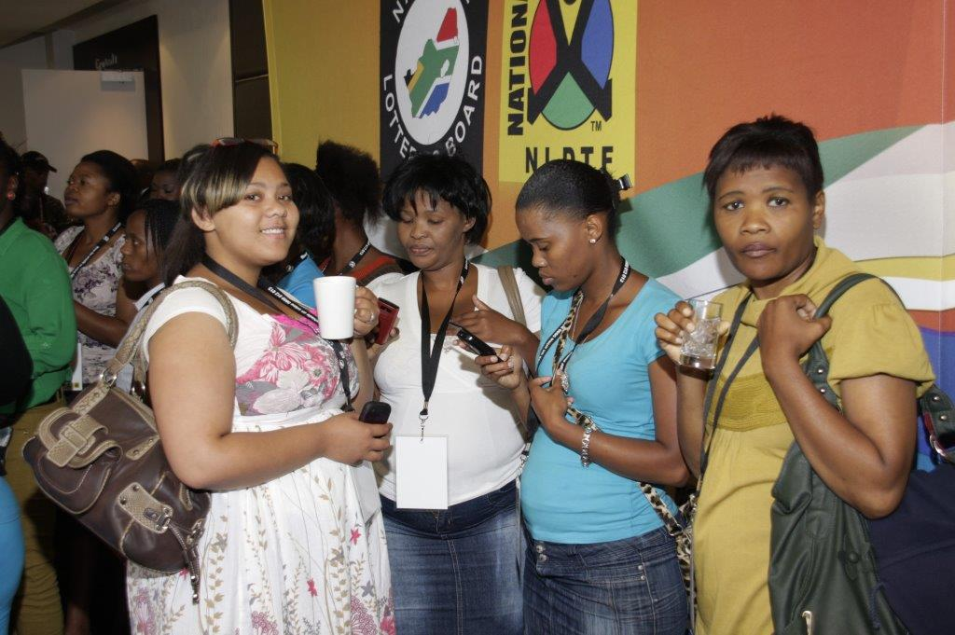These statistics belong to us- and the public health, how do we create action when
  + we are not aware of the knowledge of how people are dying, and what is causing death in childbearing woman. For example certain departments have not been able to produce statistics due to the lack of reporting from woman of cases of domestic violence. In other cases reporting is not done, as they have not come up with the methodology to do so.
  + The HIV positive people go to the clinic too late for it to be cured or for it to be treated. More clinics and access to these services is needed, for the lives of woman to be saved.
  + There is the issue of the violation of rights, after a woman has been given birth, then the woman can become mentally ill, if she does not have the right care and support around her. As many woman are victims of domestic violence, it is then vitally important that they get the care and attention as needed.
  + There should be things done around forensics- there needs to be more evidence for woman.
  + There needs to be conclusive evidence- as this will be challenged in court. Currently women are not aware, as well as SAPS of the importance of clinical evidence in court. It is through this oversight, that many perpetrators and cases cannot be pursued in court, due to the fact that there is no proof.
  + There should be no violations of confidentiality. Women are worried that their partners or communities will find out about the abuse that they have had to ensure, or that there case of assault will become public. For some women, this may put them off reporting the perpetrator.
  + National Health Insurance- needs to cover woman for all issues. At present it does not cover critical issues that arise when a women has been raped or assaulted. The government needs to become accountable in providing woman with better health care, and access to services.
  + If you are a pregnant disabled woman- there is great humiliation- they will ask- how can you manage to have a baby, how you handle this child. This needs to be addressed. Although there are programs to help women with disabilities, more needs to be done to ensure that women with disabilities get the attention and health care that is needed, without having to endure any humiliation.

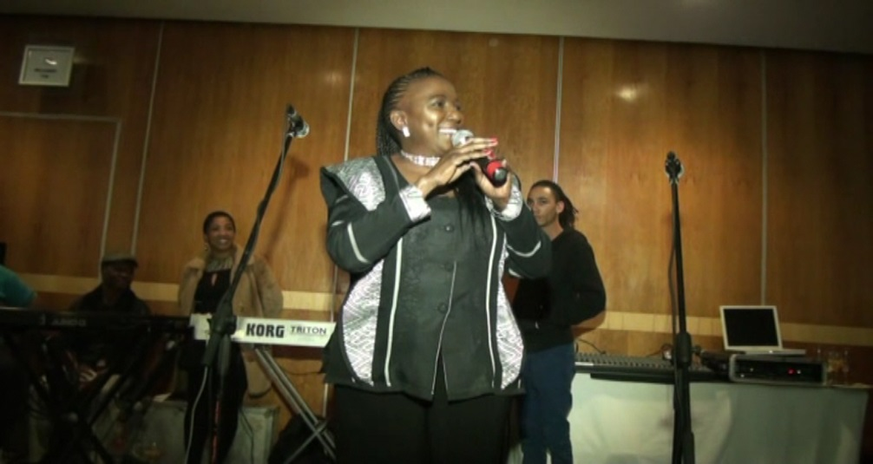

*Ms. Mara Louw Guest from Gauteng*